HRRN Scheduling-

In HRRN Scheduling,
- Out of all the available processes, CPU is assigned to the process having highest response ratio.
- In case of a tie, it is broken by FCFS Scheduling.
- It operates only in non-preemptive mode.

Calculating Response Ratio-

Response Ratio (RR) for any process is calculated by using the formula-



where-
- W = Waiting time of the process so far
- B = Burst time or Service time of the process

Advantages-

- It performs better than SJF Scheduling.
- It not only favors the shorter jobs but also limits the waiting time of longer jobs.

Disadvantages-

- It can not be implemented practically.
- This is because burst time of the processes can not be known in advance.

PRACTICE PROBLEM BASED ON HRRN SCHEDULING-

Problem-

Consider the set of 5 processes whose arrival time and burst time are given below-

Process Id | Arrival time | Burst time
P0 | 0 | 3
P1 | 2 | 6
P2 | 4 | 4
P3 | 6 | 5
P4 | 8 | 2

If the CPU scheduling policy is Highest Response Ratio Next, calculate the average waiting time and average turn around time.

Solution-

Step-01:

- At t = 0, only the process P0 is available in the ready queue.
- So, process P0 executes till its completion.

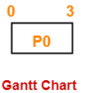

Step-02:

- At t = 3, only the process P1 is available in the ready queue.
- So, process P1 executes till its completion.

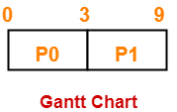

Step-03:

- At t = 9, the processes P2, P3 and P4 are available in the ready queue.
- The process having the highest response ratio will be executed next.

The response ratio are-
- Response Ratio for process P2 = [(9-4) + 4] / 4 = 9 / 4 = 2.25
- Response Ratio for process P3 = [(9-6) + 5] / 5 = 8 / 5 = 1.6
- Response Ratio for process P4 = [(9-8) + 2] / 2 = 3 / 2 = 1.5

Since process P2 has the highest response ratio, so process P2 executes till completion.

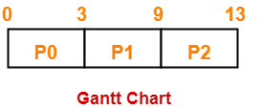

Step-04:

- At t = 13, the processes P3 and P4 are available in the ready queue.
- The process having the highest response ratio will be executed next.

The response ratio are calculated as-
- Response Ratio for process P3 = [(13-6) + 5] / 5 = 12 / 5 = 2.4
- Response Ratio for process P4 = [(13-8) + 2] / 2 = 7 / 2 = 3.5

Since process P4 has the highest response ratio, so process P4 executes till completion.

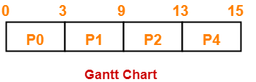

Step-05:

- At t = 15, only the process P3 is available in the ready queue.
- So, process P3 executes till its completion.

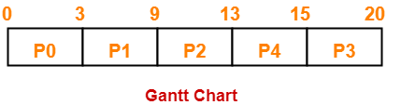

Now, we know-
- Turn Around time = Exit time – Arrival time
- Waiting time = Turn Around time – Burst time

Also read- Various Times of Process

Process Id | Exit time | Turn Around time | Waiting time
P0 | 3 | 3 – 0 = 3 | 3 – 3 = 0
P1 | 9 | 9 – 2 = 7 | 7 – 6 = 1
P2 | 13 | 13 – 4 = 9 | 9 – 4 = 5
P3 | 20 | 20 – 6 = 14 | 14 – 5 = 9
P4 | 15 | 15 – 8 = 7 | 7 – 2 = 5

Now,
- Average Turn Around time = (3 + 7 + 9 + 14 + 7) / 5 = 40 / 5 = 8 units
- Average waiting time = (0 + 1 + 5 + 9 + 5) / 5 = 20 / 5 = 4 units

